Accounting Hub – Non Functional Requirements

Author: Shishir Narain  
Architect- Accounting Hub

Lloyds Banking Group

Version 0.1

# Document History

## Document Location

This is a snapshot of an on-line document. Paper copies are valid only on the day they are printed. Refer to the author if you are in any doubt about the currency of this document.

## Revision History

|  |  |  |
| --- | --- | --- |
| Revision Number | Revision Date | Summary of Changes |
| 0.1 | 10/02/2013 | Original draft for internal review |
|  |  |  |

## Approvals

This document requires following approvals. Signed approval forms are filed in the Quality section of the PCB.

|  |  |
| --- | --- |
| Name | Title |
|  |  |
|  |  |

## Distribution

This document has been distributed to

|  |  |
| --- | --- |
| Name | Title |
| ? | ? |

# Contents

1. Document History 2

1.1 Document Location 2

1.2 Revision History 2

1.3 Approvals 2

1.4 Distribution 2

2. Contents 3

3. Introduction 4

3.1 Load Pattern 4

3.2 System Usage 4

3.3 Volumetrics 5

3.4 Data Archival Requirements 5

3.5 Availability 5

3.6 Instance Strategy 6

3.7 Deployment Topology & Disaster Recovery 6

3.8 Deployment Units 6

# Introduction

This document captures the Non Functional Requirements for Accounting Hub platform. This document will be modified as new programs and services are on boarded.

## Load Pattern

The request load profile on Accounting Hub from various programs is as below:

**CBO**

Account Inquiry Service 10 Account                    10%

Account Inquiry Service 50 Account                      3%

Account Inquiry Service 1 Account                    77%

Account Posting Service   10%

Only 10% of the Account Inquiry calls have Account Indicator = true flag

**CHAPS**

Account Posting Service (rCBS) 100%

**International**

Account Posting Service (wCBS) less

Account Posting Service (NCA) more

Account Posting Service (IF) less

Account Posting Service (TD01) very few

## Response Time SLA (90% percentile)

The Service Level Agreement for the various Accounting Hub Services is:

Account Inquiry Service 10 Account              5 sec

Account Inquiry Service 10 Account               10 sec

Account Inquiry Service 10 Account                    1 Sec

Account Posting Service (CHAPS/INTL/CBO)      4 sec

ACH will respond within the above duration in 90% cases.

## System Usage

**Broker CPU**

The Broker CPU usage should be less than 40%. As current deployment topology is Active-Active, single machine should be able to process the entire load so CPU shouldn’t go beyond 40%.

**Broker MQ**

The Broker memory usage should be <<>>

**MQ**

No long term queue buildup

No high file system usage < 60%

**DB2**

<<Add stuff here>>

## Volumetric

The projected peak TPS on Accounting Hub from various programs is shown below:

**Program Peak TPS**

CBO 1 (as on date), 27 (2017), 120?? DR

CHAPS 6

International 1

FCM 30

H2H (on-hold) 7.5

<<Add reference to the program documents>>

## Data Archival Requirements

ACH will keep application data in live tables for 30 days. Older data will first be archived to Mainframe file system, followed by archival to tape after <<>>. It is retained on tape for <<>> years.

<<Add reference to the archival policy descision>>

## Availability

ACH is Tier A application which mandates 24* 7 availability. The availability requirement for the various programs is show below:

CBO – 24*7 for Account Enquiries and Account Postings

CHAPS – 6am to 6pm (8pm for CHAPS extension), Mon – Fri

International - 6am to 6pm (8pm for CHAPS extension), Mon – Fri

FCM - <<>>

## Security

ACH is not exposed to external parties as the entire application and the integration partners are within LBG network. ACH doesn’t have any GUI, so there are no external users. The application is used only by other applications, so no user security is required. Access to product files and logs are governed by the normal Operating System group access controls.

The integration with other applications are using

1. MQ: secured using SSL
2. http: secured using SSL

Access to production data is controlled via DB2 access controls.

## Instance Strategy

Same instance of Accounting Hub application will be used for CBO, CHAPS, International, and FCM projects.

## Disaster Recovery

Accounting Hub application is deployed at Horizon Data Centre and Peterborough2. The SLA for DR site recovery is <<>>

<<This picture is not correct. Needs to be updated>>

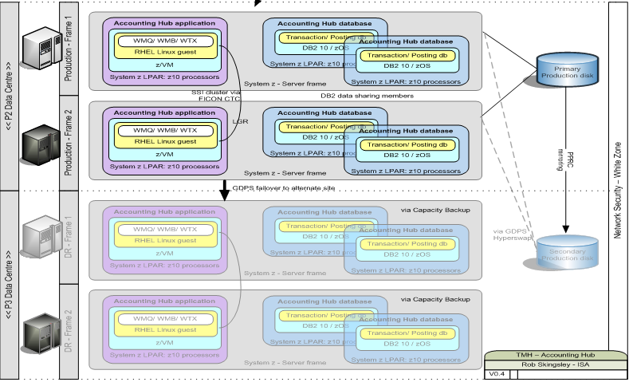

## Deployment Units

Currently there are 2 machines (P1 and P2) each having an instance of Message broker. Both of the brokers are in active-active mode. The EGs/Flows on both the brokers are identical.

**Execution Group Component**

InterfaceHandlers_01_01 Client Interface Handlers

InterfaceHandlers_02_01 Provider Interface Handlers

InterfaceHandlers_02_02 Provider Interface Handlers - Replica

MicroHub_01_01 Microkernel

MicroHub_01_02 Microkernel - Replica

MicroHub_02_01 Internal Servers

MicroHub_03_01 Common Components

MicroHub_03_02 Common Components - Replica

PlatformMaps_01_01 Interface Maps